**What is Smart Grid Management?  
  
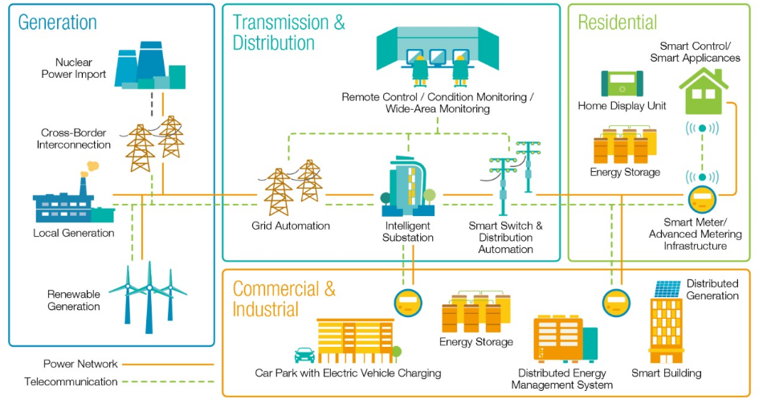**

Img Source: https://www.elprocus.com/overview-smart-grid-technology-operation-application-existing-power-system/

Smart Grid Management is an advanced system that utilizes digital technologies and communication networks to enhance the efficiency, reliability, and sustainability of the electricity grid. It enables the integration of renewable energy sources, such as solar and wind, and establishes a two-way communication system between electricity providers and consumers. By leveraging sensors, smart meters, and data analytics, the system can monitor and manage energy consumption in real time, facilitating more effective energy use and reducing peak demand. Additionally, utilities can quickly detect and respond to power outages and other issues, improving the overall dependability of the grid. Smart Grid Management is a critical element in the transition to a more sustainable and resilient energy system.

Before the modernization of the grid, the electric grid was managed through a one-way communication system where electricity flowed from the power plant to the customers. This system could not handle the integration of renewable energy sources, which caused challenges in managing peak loads and resulted in high operational costs.1

#### Sources:

1. Department of Energy. "Grid Modernization and the Smart Grid." <https://www.energy.gov/oe/grid-modernization-and-smart-grid>. ↩

Smart Grids function by integrating advanced technologies and systems that allow for real-time monitoring, analysis, and control of power generation, transmission, and distribution.

The process of implementing Smart Grids in the real world involves several steps, including:

* Deployment of Advanced Metering Infrastructure (AMI): This involves the installation of smart meters that record and transmit energy usage data in real-time. Utilities can then monitor and analyze energy consumption patterns and identify opportunities for load management and peak shaving.
* Integration of Communication and IT Systems: Smart Grids require a reliable and secure communication infrastructure to enable the exchange of data between different parts of the grid. This can involve the use of wireless or wired networks, fiber-optic cables, and other communication technologies.
* Implementation of Automation and Control Systems: Smart Grids use advanced automation and control systems to enable real-time monitoring and control of power flows, including the ability to curtail loads and adjust power generation in response to changes in demand or supply.
* Deployment of Distributed Energy Resources (DERs): DERs such as solar panels, wind turbines, and energy storage systems can be integrated into the grid and managed through Smart Grid Management systems. This enables greater control and flexibility in the distribution of energy and facilitates the integration of renewable energy sources.

**Benefits**

It is evident that Smart Grid Management offers a plethora of benefits that can significantly improve the efficiency, reliability, and sustainability of the power grid. By utilizing advanced technologies such as real-time monitoring and control, Smart Grid Management enables utilities to reduce energy waste, optimize energy consumption, and integrate renewable energy sources into the grid.

Moreover, Smart Grid Management can enhance the reliability and resilience of the power grid, facilitating faster restoration of power in case of an outage. Additionally, Smart Grid Management enables better asset management by monitoring the condition of equipment in real-time and promoting effective maintenance practices.

Furthermore, the implementation of demand response programs and load-shifting strategies can help utilities better manage peak demand, reducing the need for costly infrastructure investments. By providing customers with real-time energy usage data, Smart Grid Management can also promote energy efficiency, reduce energy bills, and enhance customer engagement.

Overall, Smart Grid Management has the potential to transform the power grid into a more efficient, reliable, and sustainable system while simultaneously reducing costs and improving customer satisfaction.

**Pros of Smart Grid Management**:

1. Improved energy efficiency: Smart Grid Management enables utilities to better manage the flow of electricity, which can help reduce energy waste and peak demand.
2. Increased reliability: Smart Grid Management can quickly detect and respond to power outages or other issues, improving overall grid reliability.
3. Integration of renewable energy sources: Smart Grid Management allows for the integration of renewable energy sources, such as solar and wind power, into the grid, thereby reducing reliance on fossil fuels and promoting sustainability.
4. Cost savings: Smart Grid Management can help reduce energy bills for consumers by enabling them to monitor and manage their energy consumption more effectively.
5. Environmental benefits: By promoting the integration of renewable energy sources and reducing reliance on fossil fuels, Smart Grid Management can contribute to a more sustainable and environmentally-friendly energy system.
6. Increased grid security: Smart Grid Management can enhance the security of the electrical grid, helping to prevent cyber attacks and other threats.

**Potential drawbacks to consider**:

1. Cybersecurity risks: Smart Grid Management relies heavily on digital communication and control systems, which can be vulnerable to cyber attacks or hacking attempts.
2. High implementation costs: Implementing Smart Grid Management systems can be expensive, requiring significant investment in new technology and infrastructure.
3. Technical complexity: Smart Grid Management systems are complex and require sophisticated technology and expertise to operate effectively, which can be a barrier to adoption for some utilities or consumers.
4. Privacy concerns: Smart Grid Management systems collect large amounts of data on energy usage and consumption patterns, raising concerns about data privacy and security.
5. Interoperability issues: Smart Grid Management systems may not be compatible with existing energy infrastructure or technologies, which can create interoperability issues and make integration more difficult.

**Implementation:**

The implementation of Smart Grid Management involves the integration of various technologies and systems to monitor and control the flow of electricity across the grid. This involves the installation of advanced sensors, meters, and other monitoring devices that can collect real-time data on energy usage, as well as the deployment of communication and control systems that can respond to changes in demand and supply.

One key aspect of Smart Grid Management is the use of advanced analytics and machine learning algorithms to analyze the data collected by these sensors and meters. This can help utilities and grid operators to forecast energy demand more accurately, optimize the use of energy resources, and identify potential issues before they become major problems.

Another important component of Smart Grid Management is the integration of renewable energy sources, such as solar and wind power, into the grid. This requires the installation of new infrastructure, such as solar panels and wind turbines, as well as the development of new energy storage technologies, such as batteries or pumped hydro storage, to address the variability and intermittency of these renewable energy sources.  
  
**AI and IoT driven Technologies:**

Img Source: https://genuspower.com/ai-and-iot-driven-smart-grid-technologies-for-smart-energy-management/

AI and IoT driven technologies are being increasingly utilized in the management of smart grids. Smart grids are an advanced type of power grid that uses digital technologies to improve efficiency, reliability, and sustainability.

Here are some ways in which AI and IoT are being used in smart grid management:

1. Predictive maintenance: With the help of IoT sensors and AI algorithms, smart grids can predict when equipment is likely to fail, allowing for maintenance to be scheduled before a failure occurs. This can reduce downtime and prevent costly repairs.
2. Demand response management: By using IoT-connected devices, such as smart thermostats, smart grids can manage energy demand by adjusting energy usage during peak periods. AI algorithms can also be used to optimize energy usage in real-time.
3. Renewable energy management: Smart grids can integrate renewable energy sources, such as solar and wind, by using AI algorithms to predict energy production and demand. This can help balance the grid and optimize the use of renewable energy sources.
4. Fault detection and outage management: IoT sensors can detect faults in the power grid and alert operators in real-time. AI algorithms can then analyze the data and help operators quickly identify the root cause of the problem and take corrective action.
5. Grid optimization: AI algorithms can analyze vast amounts of data from the power grid, such as energy usage patterns, weather forecasts, and historical data, to optimize grid performance and reduce energy waste.

**Data analysis in Smart Grid Management:**

Img Source : https://www.researchgate.net/figure/Scenario-2-Distributed-Data-Analytics-for-Smart-Grids_fig11_295893564

***Smart Grid Management relies on the collection and analysis*** of vast amounts of data to optimize energy usage, reduce costs and promote sustainability. This data is collected through sensors and meters installed throughout the grid, which measure various aspects of energy usage, such as power demand, voltage, and frequency.

One of the key benefits of Smart Grid Management is the use of advanced analytics and machine learning algorithms to analyze this data. These algorithms can process and analyze large amounts of data quickly and accurately, allowing utilities and grid operators to identify patterns and trends in energy usage, forecast demand, and optimize the use of energy resources.

For example, analytics can help utilities to identify areas of the grid that are experiencing high demand and allocate resources accordingly. They can also identify areas where energy is being wasted or used inefficiently, allowing utilities to take steps to reduce energy consumption and costs.

Data analysis also plays a crucial role in the integration of renewable energy sources into the grid. The variability and intermittency of renewable energy sources, such as solar and wind power, can make them challenging to integrate into the grid. However, by analyzing data on energy usage and weather patterns, utilities can predict when and where renewable energy sources are most likely to be available, and adjust the grid accordingly.

Implementing data analysis in Smart Grid Management involves several steps:

Data collection: Smart Grid Management systems use sensors and meters to collect data on energy usage, supply, and demand. This data is then stored in a central database for analysis.

Data pre-processing: Before analysis can begin, the collected data must be cleaned and pre-processed to remove any errors or inconsistencies.

Data analysis: Once the data has been pre-processed, advanced analytics and machine learning algorithms can be used to analyze the data and identify patterns and trends in energy usage, demand forecasting, and resource optimization.

Decision-making: The insights gained from data analysis can be used to make informed decisions about resource allocation, energy management, and infrastructure development.

Implementation: The decisions made based on data analysis are then implemented, often through the use of automation and control systems, to optimize energy usage and improve the efficiency and reliability of the grid.

Intelligent data collection devices, such as smart meters, sensors, and other monitoring and control systems that are connected to the grid, are used in Smart Grid Management to collect data on energy usage, grid conditions, and other relevant information.

By collecting data in real-time, these devices provide utilities and grid operators with valuable insights into energy consumption patterns, grid conditions, and other factors that can affect the performance and efficiency of the grid. The data collected can then be analyzed using advanced analytics and machine learning algorithms to identify patterns and trends, forecast demand, and optimize the use of energy resources.

Moreover, these devices can help utilities to quickly detect and respond to power outages and other issues, improving the reliability and dependability of the grid. In addition, they enable consumers to monitor and manage their energy consumption more effectively, which can help reduce energy bills and promote energy conservation.  
 **Intelligent data collection devices in Smart Grid Management :**

Intelligent data collection devices, such as smart meters, sensors, and other monitoring and control systems that are connected to the grid, are used in Smart Grid Management to collect data on energy usage, grid conditions, and other relevant information.

By collecting data in real-time, these devices provide utilities and grid operators with valuable insights into energy consumption patterns, grid conditions, and other factors that can affect the performance and efficiency of the grid. The data collected can then be analyzed using advanced analytics and machine learning algorithms to identify patterns and trends, forecast demand, and optimize the use of energy resources.

Moreover, these devices can help utilities to quickly detect and respond to power outages and other issues, improving the reliability and dependability of the grid. In addition, they enable consumers to monitor and manage their energy consumption more effectively, which can help reduce energy bills and promote energy conservation.

Implementing intelligent data collection devices is crucial to Smart Grid Management, as it enables utilities and consumers to make more informed decisions, reduce energy consumption and costs, and promote the integration of renewable energy sources into the grid.

**Data Science in Smart Grid Management :**

Data science plays a significant role in Smart Grid Analytics. It involves the use of advanced analytical techniques and machine learning algorithms to analyze vast amounts of data collected from the smart grid devices.

The insights gained from data science can help utilities optimize their energy distribution, reduce energy waste, and improve the efficiency of the grid. This can lead to significant cost savings for both utilities and consumers. For example, by using data science techniques to analyze energy usage patterns, utilities can identify areas where energy consumption is high and work to reduce it through targeted energy efficiency initiatives.

Furthermore, data science can help utilities integrate renewable energy sources into the grid. By analyzing data on energy usage and weather patterns, utilities can predict when and where renewable energy sources are most likely to be available and adjust the grid accordingly. This can help reduce the reliance on fossil fuels and promote the use of sustainable energy sources.